MONTHLY TEST- DECEMBER- 2019
Marks obtained:

Total:
30
Name: _______________________
Grade: II Section___
Subject: Maths
Date:16.11.19
Time: 1 Hour

I. Write the number names for the numbers. (3x1=3)
a) 456 - ________________________________________________________
b) 687 - ________________________________________________________
c) 833 - ________________________________________________________
II. Expand the following. (3x1=3)
a) 481- _______________________________________________________
b) 128 - ______________________________________________________
c) 763 - _______________________________________________________
III. Fill in the missing numbers. (3x2=6)
a) _____, ______, 356, _______, ______,
b) 823, ______, ______, ______, ______,
c) 218, _____, 220, _____, ______, _____,
IV. Fill in the blanks with <, >, = (5x1=5)
a) 809 ______ 921
b) 120 ______ 102
c) 430 ______ 430
d) 199 _____ 162
e) 1000 _____ 100
V. Arrange the numbers in ascending order. (2x2=4)

345 | 213 | 122 | 651

430 | 712 | 534 | 900

VI. Colour the balls of abacus to show the number given below. (6x1=6)

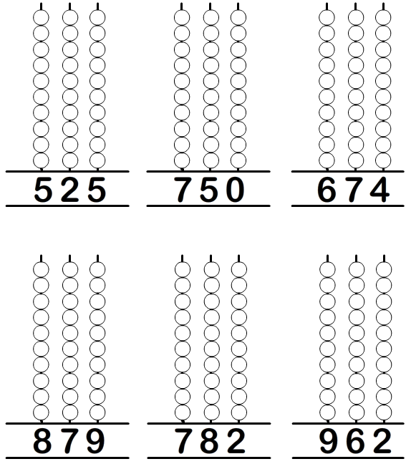

VII. Compare the volume of the liquid. and write ‘more’ or ‘less’ . (6X½=3)
